Pydantic models are the standard way to define structured request data (inputs) and response data (outputs) in modern Python web frameworks like FastAPI.

CAPSTONE PROJECT #1: Build a naive RAG system for loan policy documents or similar with FastAPI endpoint.

Create a folder loan_rag_api
Inside that create documents folder and inside that laon_policy.txt
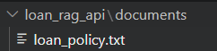

Loan_policy.txt
LOAN POLICY

Personal Loan Eligibility:

Applicants must be at least 21 years old.

The applicant must have a minimum monthly income of Rs. 25,000.

The applicant must have a valid government identity document.

Required Documents:

Applicants must provide Aadhaar card, PAN card, proof of income, and bank statements.

Loan Amount:

Eligible customers can apply for a personal loan between Rs. 50,000 and Rs. 10,00,000.

Repayment:

The loan repayment period can range from 12 months to 60 months.

Interest:

The applicable interest rate depends on the customer's eligibility and loan amount.

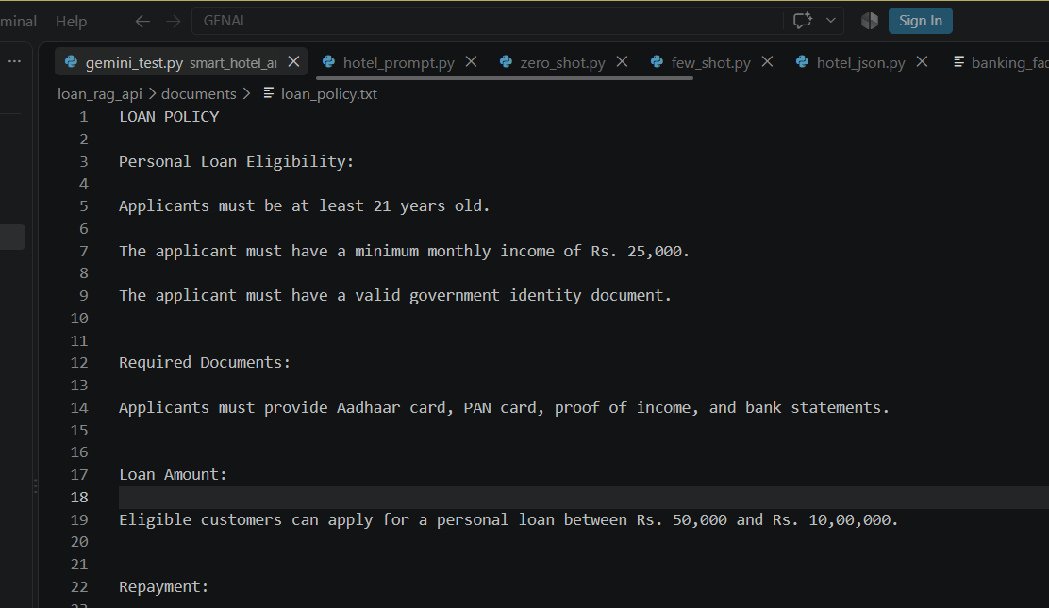

Now we'll create our first file in the main project folder.

requirements.txt
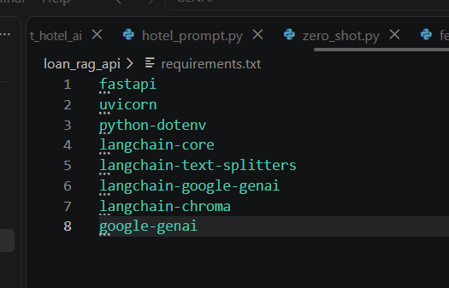

Create .env

.env
GOOGLE_API_KEY=YOUR_API_KEY_HERE

Now we'll create the three Python files.

ingest.py
rag.py
main.py
Now we're going to create an isolated Python environment for this project.

Activate the virtual environment

Install the required packages

pip install -r requirements.txt
When it finishes, run:
pip list

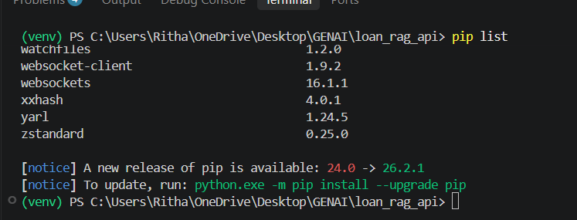

Ingest.py

pip install langchain-huggingface

from dotenv import load_dotenv
load_dotenv()

from langchain_core.documents import Document
from langchain_text_splitters import RecursiveCharacterTextSplitter
from langchain_huggingface import HuggingFaceEmbeddings
from langchain_chroma import Chroma

# --------------------------------------------------
# 1. Read the loan policy document
# --------------------------------------------------

with open("documents/loan_policy.txt", "r", encoding="utf-8") as file:
text = file.read()

print("Loan policy document loaded successfully!")

# --------------------------------------------------
# 2. Convert text into a LangChain Document
# --------------------------------------------------

document = Document(
page_content=text,
metadata={
"source": "loan_policy.txt"
}
)

# --------------------------------------------------
# 3. Split document into chunks
# --------------------------------------------------

splitter = RecursiveCharacterTextSplitter(
chunk_size=300,
chunk_overlap=50
)

chunks = splitter.split_documents([document])

print(f"Created {len(chunks)} chunks")

# --------------------------------------------------
# 4. Create local embeddings
# --------------------------------------------------

embeddings = HuggingFaceEmbeddings(
model_name="sentence-transformers/all-MiniLM-L6-v2"
)

print("Local embedding model created successfully!")

# --------------------------------------------------
# 5. Store chunks and embeddings in ChromaDB
# --------------------------------------------------

vectorstore = Chroma.from_documents(
documents=chunks,
embedding=embeddings,
persist_directory="./chroma_db"
)

print("Loan policy stored in ChromaDB successfully!")

Run ingest.py
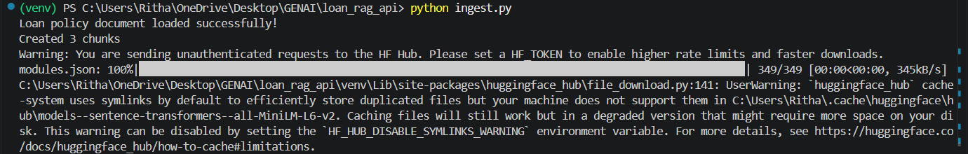

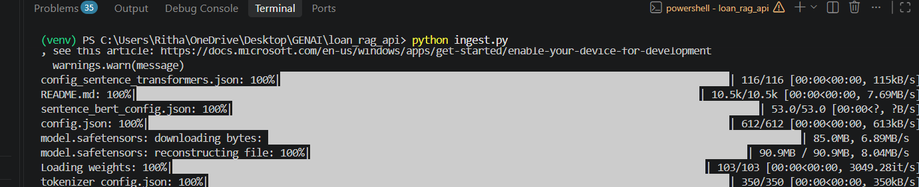

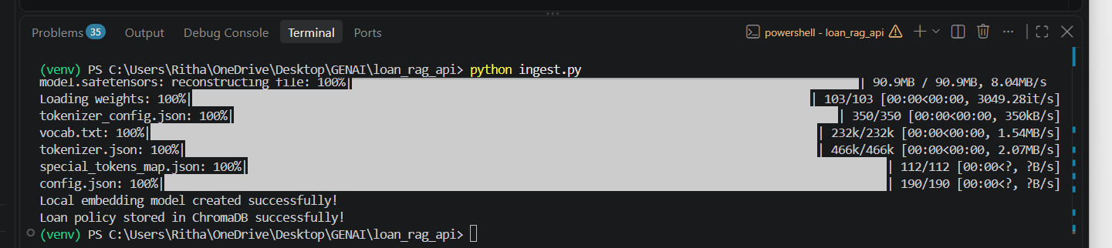

rag.py

from dotenv import load_dotenv
load_dotenv()

from langchain_huggingface import HuggingFaceEmbeddings
from langchain_chroma import Chroma
from google import genai

# --------------------------------------------------
# 1. Create the SAME local embedding model
# --------------------------------------------------

embeddings = HuggingFaceEmbeddings(
model_name="sentence-transformers/all-MiniLM-L6-v2"
)

# --------------------------------------------------
# 2. Connect to our existing ChromaDB
# --------------------------------------------------

vectorstore = Chroma(
persist_directory="./chroma_db",
embedding_function=embeddings
)

# --------------------------------------------------
# 3. Create Gemini client
# --------------------------------------------------

client = genai.Client()

# --------------------------------------------------
# 4. RAG function
# --------------------------------------------------

def ask_rag(question: str):

# Search ChromaDB for relevant chunks
results = vectorstore.similarity_search(
question,
k=3
)

# Combine the retrieved chunks
context = "\n\n".join(
doc.page_content
for doc in results
)

# Create the prompt for Gemini
prompt = f"""
You are a helpful loan policy assistant.

Answer the user's question using ONLY the information
provided in the context below.

CONTEXT:
{context}

QUESTION:
{question}

If the answer is not available in the context,
say:

"The information is not available in the loan policy."
"""

# Send the prompt to Gemini
response = client.models.generate_content(
model="gemini-3.6-flash",
contents=prompt
)

return response.text

# --------------------------------------------------
# 5. Test the RAG system
# --------------------------------------------------

if __name__ == "__main__":

question = "What is the minimum age for a personal loan?"

answer = ask_rag(question)

print("\nQuestion:")
print(question)

print("\nAnswer:")
print(answer)

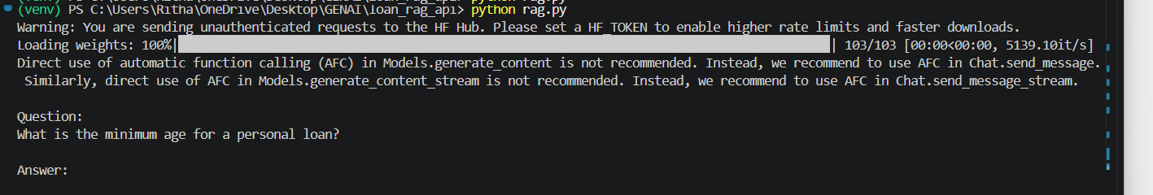

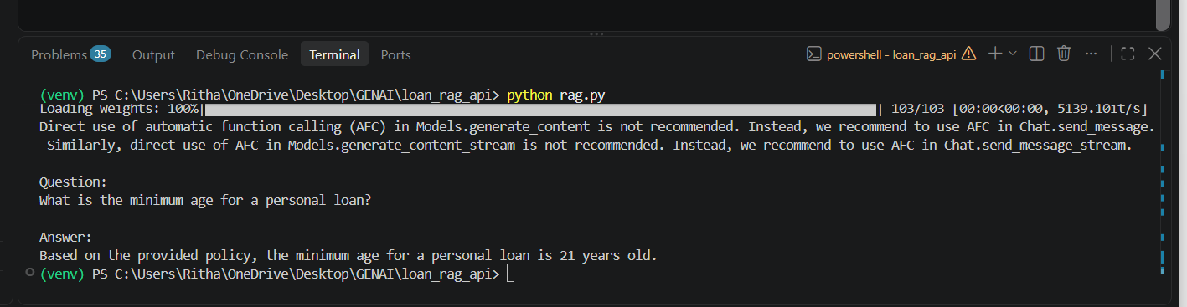

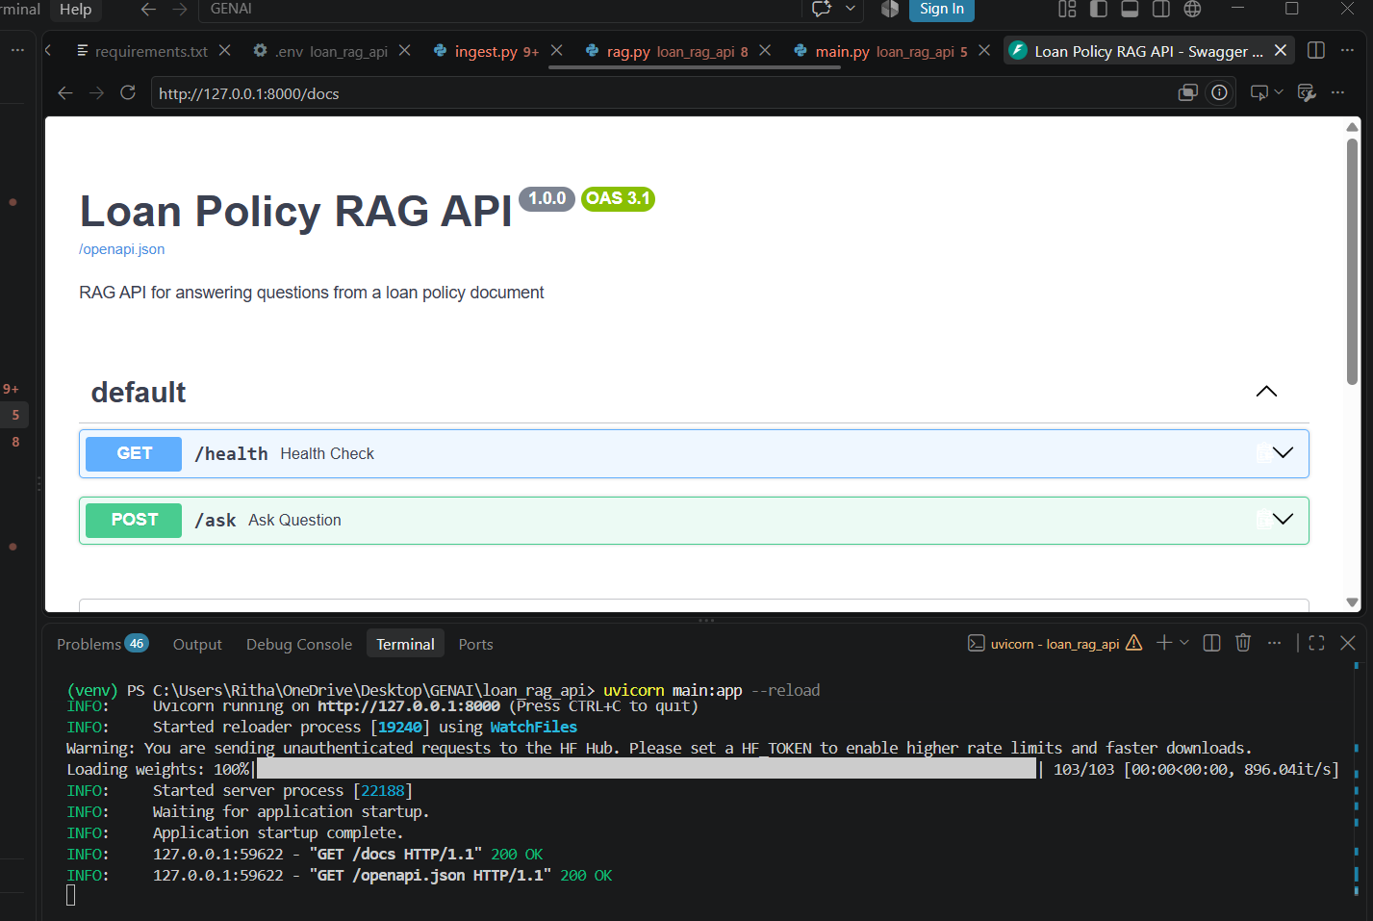

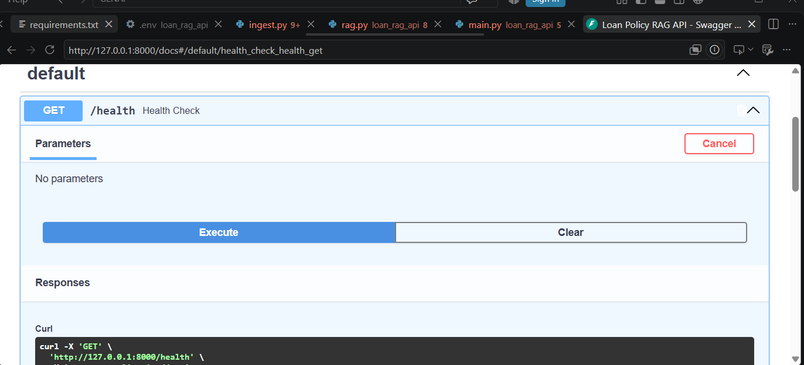

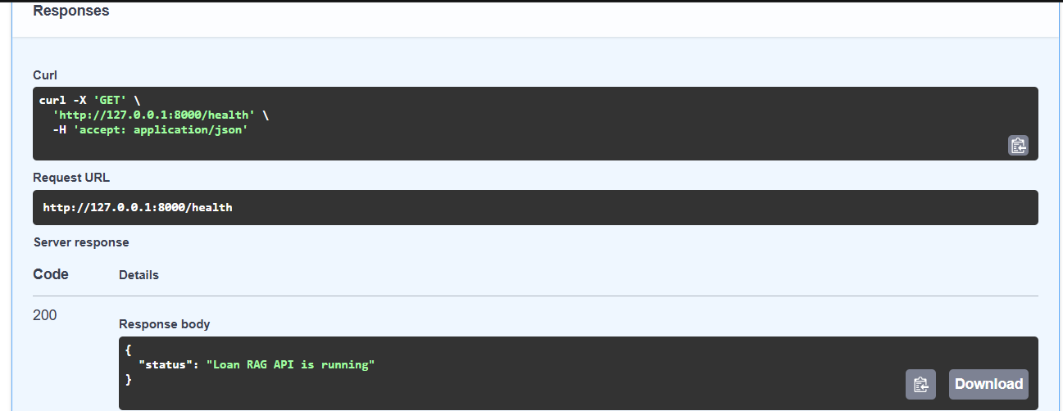

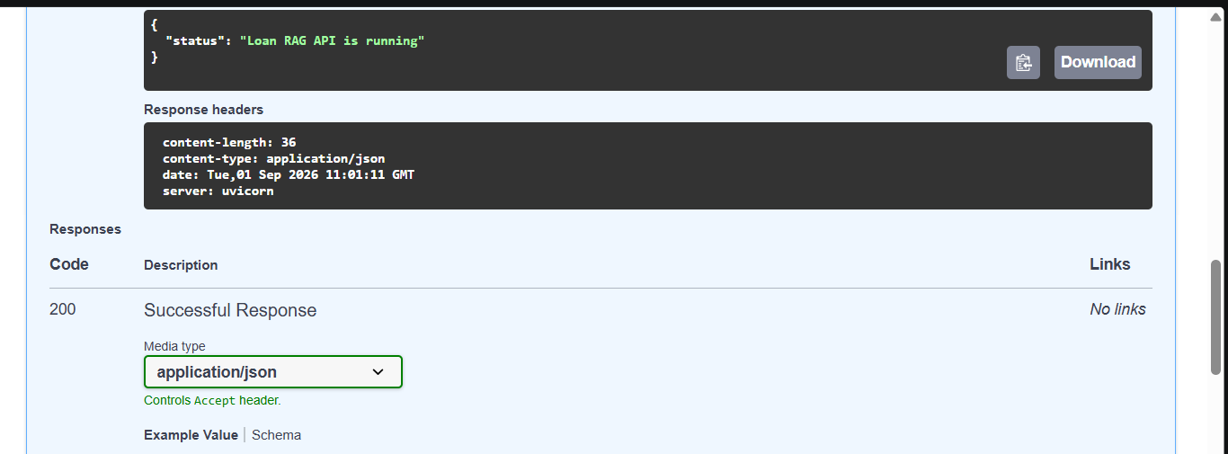

POST

